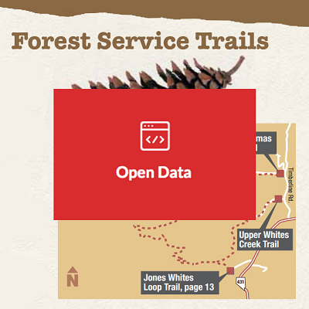
Open Data Day
is a gathering of citizens in cities around the world to write applications, liberate data, create visualizations and publish analyses using open public data to show support for and encourage the adoption open data policies by the world's local, regional and national governments.

Project
Open Trails – a website and data set with resources about Truckee Meadows Trails. Personalized content from the Truckee Meadows Park Foundation, Keep Truckee Meadows Beautiful, Truckee River Guide, Washoe County, City of Reno, City of Sparks, and more! Adding/Modernizing the Washoe County Regional Trail Guide
Bring your expertise and creative powers to a team that can help make it reality!

Time
February 21st, 2015 - 9:00 am to 4:00 pm
Location
Reno Collective, 100 North Arlington Avenue #100, Reno, NV 89501
What is the Reno Collective? The Reno Collective is a physical co-workings space in downtown Reno where members work on their projects and discover collaborative opportunities. Entrepreneurs rely on the support network to launch technical and creative projects.
Four Ps for 2015 Participation | Partners | People | Plans
We don't believe in New Year's Resolutions, but we do believe 2015 is the year to turn it up to 100+. How? The Collective has restructured meetups to be goal and project driven.
Contact
monica@monicacthompson.com

